November 2023
Dear Friend,

With the holiday season approaching, we want to take a moment to express our heartfelt gratitude for your unwavering support throughout the years. As we look back, we’re reminded of the many lives impacted by our transformative work made possible by the generosity of individuals like you!

We’d like to share the remarkable story of Hailey, a brave young woman who has shown us the true power of determination, resilience, and grit. At the age of 15, Hailey learned that she was one of two individuals in Maine with Wolfram Syndrome, a rare genetic condition that comes with challenges like diabetes, hearing loss, and optic atrophy. Despite her sight loss, Hailey has never given up on her dreams and is determined to navigate the world with independence and confidence!

Thanks to the exceptional orientation and mobility (O&M) services provided by The Iris Network, Hailey has been able to conquer daily challenges like going to the grocery store, visiting a coffee shop, or taking the bus. With newfound confidence, she learned to skillfully plan and execute bus routes throughout Portland, and more recently, navigated her way through Boston with ease.

Hailey was so much fun to work with. She was energetic, eager to learn, and was motivated to continue improving her independence. With these skills there is no doubt she will accomplish great things! ~ Hannah, O&M Instructor

Hailey greatly benefited from the technology classes offered by The Iris Network, as they equipped her with the necessary skills to excel in multiple aspects of her life. These skills included the ability to effectively use a computer, mobile device, and screen reader.

Hailey acknowledges the exceptional guidance of our Certified Assistive Technology Instructional Specialists (CATIS), Sara and Aisha, for teaching her advanced skills that she can utilize daily, whether it be at home, school, or work.

I applaud the CATIS instructors, Sara and Aisha, they are fantastic! ~ Hailey

During Hailey’s time at The Iris Network, she even learned Braille. By learning Braille, Hailey has acquired a valuable skill that has given her the ability to have equal access to literature and its joys.

In addition to these practical skills, Hailey gained valuable insight into her desired career path by meeting with our Director of Human Resources, Kristen. Hailey is currently pursuing a degree in Business Administration with a concentration in Human Resources, and we’re excited to see where her career will take her.

Hailey is independent, brave and has a good head on her shoulders. She has a lot of ambition and will go far. ~ Kristen, Director of Human Resources

Hailey's story is a powerful reminder of the transformative impact that The Iris Network has on the lives of those with vision impairments. As a nonprofit organization, we rely on the generosity of donors like you to continue providing crucial support to individuals in need. As you consider your charitable giving this holiday season, we humbly ask that you donate to our mission. Your support will make a meaningful difference in the lives of those we serve and enable us to continue our life-changing work.

Thank you again for your continued support and commitment to our mission. Together, we can make a brighter, more inclusive future for all.

Warm regards,
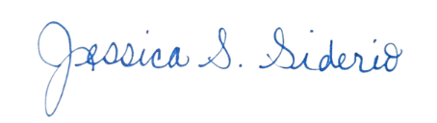
David Barnwell, DBA, MBA Jessica Siderio
President & Executive Director Director of Development & Communication

PS. To make a gift to The Iris Network this holiday season, please return the enclosed envelope. For online payments please visit www.theiris.org/donate or
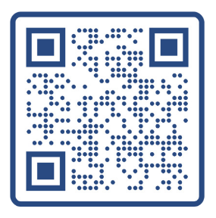
scan the QR code.

