
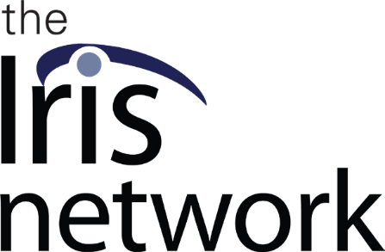


May 2023

Dear Friend,
Making a meaningful difference in the lives of individuals who have
lost their sight or have a visual impairment is truly remarkable. It is due to the generous support and kindness of donors such as yourself that individuals like Thalia have been able to benefit from The Iris Network services.

The Iris Network saved my life! ~ Thalia
Thalia is an inspirational woman whose love for life, even at nearly 97 years old, is contagious. Nothing has stopped her from doing the things she wants to do, including her passion for reading, attending pottery classes, and hosting dinner parties for her friends, despite the macular degeneration that has caused her to lose her central vision, the most common cause of vision loss in the United States.
Because of you, Thalia has been able to continue living independently in her own home and community, thanks to the life-changing impact made possible through our programs and services at The Iris Network.

Anyone who needs help should never hesitate to reach out to The Iris Network. Vision loss isn’t something that only happens to
older people; it can happen to anyone at any age.
Donations made this spring will have an even greater impact on the visually impaired community. Each gift, up to $10,000, will be matched by an anonymous donor, dollar for dollar! These gifts do much more than fund programs; they also give individuals with blindness or vision impairment the opportunity to gain confidence, renew hope, and drastically improve their quality of life.

I’m so thankful to The Iris Network for the amazing work they do and for helping me feel more independent and empowered.

Our Certified Vision Rehabilitation Therapists (CVRTs) provide one-on-one sessions that teach adapted living skills to the client, in their own home or workplace. The assistance provided varies greatly, from learning how to use technology or Braille to stay in their current job, to getting help with simpler daily tasks such as reading, cooking, cleaning, and navigating.

It is a privilege to work with clients such as Thalia. Nothing stops her from doing what she wants to keep doing. She will find a way to keep going such as asking The Iris Network for assistance to achieve it. ~ Amber, CVRT
In Thalia’s words: “The Iris Network saved my life!” Many feel hopeless when they lose their sight, but with your help The Iris Network can continue to offer tailored programs and services individualized for each client to best meet their needs. With the use of adaptive and assistive technology the client can achieve their goals for education, employment, avocation, and independence.
Thalia’s objective was to keep on reading, maintain financial independence, and remain a vital member of her community. With the help of The Iris Network, she not only developed the adaptive abilities necessary for daily life but also mastered the use of an iPad.
Your contribution this spring is sure to have an amazing and life-changing impact.
Now is the time to show your continued commitment and double the impact of your donation. Will you consider a gift today? Every donation matters and with your spring gift, The Iris Network can reach more people and extend even more of our services and resources to those with vision loss.
Thank you for creating meaningful and positive change in the lives of people living in your community.

Gratefully yours,

David Barnwell, DBA, MBA President & Executive Director
Jessica S. Siderio
Director of Development & Communication



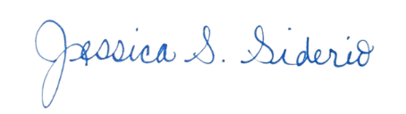

PS. This spring your tax deductible gift will go even further to help more people with sight loss or vision impairment continue to live life to their fullest, no matter their age. Each gift, up to $10,000, will be matched by an anonymous donor, dollar for dollar!

