insight

IMPACT REPORT | WINTER 2022

From our Executive Director

























































As always, thank you!
I’m pleased to share that we have been able to continue to successfully provide our critical vision rehabilitation along with our other comprehensive programs to serve those who are blind or visually impaired throughout this pandemic.

You never cease to amaze me.
I want to emphasize the impact that your donations continue to make in supporting our friends and neighbors who benefit from our services, especially during this challenging time.
As we are being careful to follow guidelines set by the Center for Disease Control (CDC) such as social distancing, we recognize that our consumers may be more socially isolated than ever before. Thanks
to you, we continue to find creative ways to provide our programs to best serve each client while remaining safe and careful.
The outpouring of support from donors like you enables us to continue to provide high-quality programming and to look for opportunities to expand our
services beyond our current offerings.
I am forever thankful for our donors, funders, staff, Board, partners including Maine’s Division for the Blind and Visually Impaired (DBVI) and Maine Medical Center, vendors, neighbors, the City of Portland, legislators, the Lions (with special mention to the Falmouth Lions), and all others who support our work.

You are helping those who have
vision loss stay in or return to the workforce or navigate their homes and towns.
We couldn’t do it without your thoughtfulness and selfless support.
I hope you enjoy reading about donors like you and the people you’ve touched with your generosity in this report.

Thank you! Gratefully yours,

Dr. David Barnwell President/ Executive Director

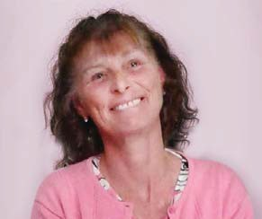
Kindness and Remarkable Courage

Tina’s story

“Kindness was something that came very easy for her,” Kelly Kingsbury says of her sister, Tina Marie Cassidy Black. “She had a loving soul. She would spend her time serving food to the community and helping the less fortunate,” Kelly recalls fondly.
And when Tina was declared legally blind, one character trait in particular shone strongly.
“Courage. Remarkable courage,” says Kelly. “Although her independence was now compromised, Tina moved forward with courage and grace.”
Tina reached out to The Iris Network, and was clever and resourceful as she used the tools and education she received at The Iris Network. “You’d never know Tina was visually impaired,” Kelly says. “She walked with her head held high and was determined to carry on with life.”
Sadly, Tina passed away in January of 2021 due to an illness. She is deeply missed by her family and remembered fondly for her kindness and courage.

An Iris Network donor herself, Tina inspired several in memorial donations. Her life and her legacy are true testaments to the powerful impact you allow The Iris Network to have on your neighbors who have vision loss.

“The Iris Network was always there for Tina Marie,” Kelly says. “I thank everyone there for their commitment and dedication to serving those who have visual impairment.”

We at The Iris Network endlessly appreciate you—our donor—for making our services available to people like Tina, empowering them to live life to the fullest every day.

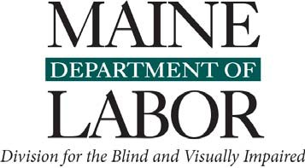
PARTNERS IN SERVICE

Update from Rugged Seas:
Nikki’s fundraiser for The Iris Network

You may remember hearing about Nikki Strout—an incredible wife, mother, and small business owner of Rugged Seas.
When her two young sons were diagnosed with a rare genetic condition that causes blindness in childhood, she felt lost. Nikki didn’t know where to go next or how to help her boys.
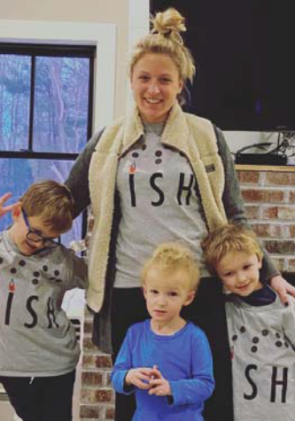
Nikki and her family attended the annual White
Cane Walk and ran into Development Director Regal Naseef. Regal informed Nikki of the organizations and services available to help her sons.
While the Maine Division for the Blind and Visually Impaired provides connections
to youth blindness services, Nikki is forever grateful to The Iris Network for the guidance she received that day.

“The Iris Network was our guiding light. We received more guidance that day at the Walk than at any doctor’s oﬃce. I couldn’t imagine being a family in our situation without knowing about The Iris Network,” Nikki says.
That’s why she and Rugged Seas made t-shirts with the word “FISH” in Braille
to sell in a fundraiser with 100% of the proceeds donated to The Iris Network— over $10,000!

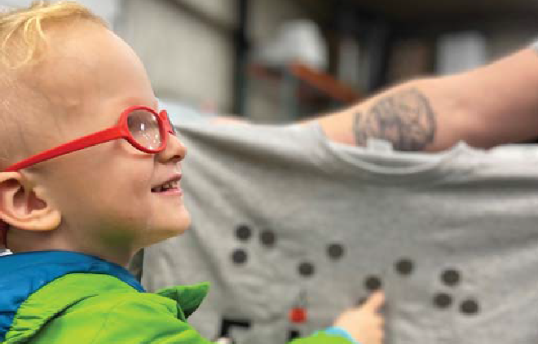
“I wanted to raise awareness and help educate people on vision loss,” Nikki says. “This world can be pretty diﬃcult for someone who is visually impaired. You need support. That’s what The Iris Network does for transition-age youth and adults here in Maine.”
“There is no cure for blindness,” she continues. “It can happen to anyone at any time, and I am so grateful for the support my sons have received from this fundraiser—physically and emotionally!”
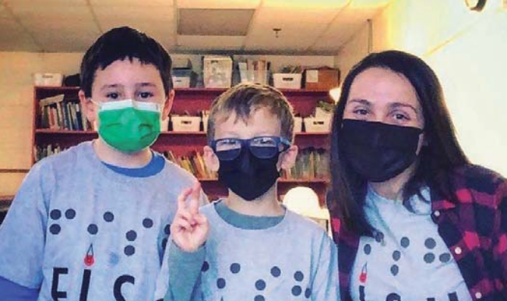
Thank you to Nikki, Rugged Seas, to all who participated, and to donors like you who help raise awareness and make our services available to your neighbors who are blind or visually impaired!

thanks to you...
In ﬁscal year 2021, we provided:


Community-based Blindness Rehabilitation Services to
554
Access technology and job coaching to
20 employees/interns

people who are blind or visually impaired in Maine

138

Adaptive devices to consumers from our Low Vision Center


Supportive housing services (24/7) to


residents of Iris Park Apartments in Portland
35
Service to a total of
760

people who are blind or visually


Employment-readiness training to
impaired for
13,547 hours

students (from Maine and New York) in our Rehabilitation Center
13

CONNECT WITH US!


Stay updated on our calendar of events at theiris.org/news-events

207-774-6273•189 Park Avenue, Portland ME 04102•
Follow and like us on Facebook at

facebook.com/TheIrisNetwork

