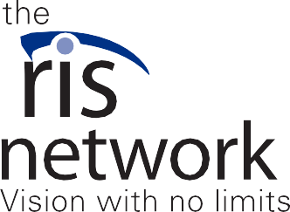
Because of The Iris Network, my world became bigger. Things were accessible once again. I no longer felt limited by my visual impairment.
“
“

Dear Friend,
When I lost my vision due to hereditary disease after completing nursing school, I knew then I’d never be able to practice as a nurse in the capacity I wanted to.
I’d spent six years in school following my passion to build a meaningful career helping others, but I was suddenly living in a world where everything seemed more difficult. I could no longer drive, and my experience with a white cane was limited so I found myself struggling on walks. I couldn’t functionally use a computer or the internet, and certainly couldn’t write a paper or update my resume.
But being young and confident, I set all my fears aside and began searching for a new career—and the technology and education I’d need to be successful.

Thanks to generous neighbors like you, I found exactly what I needed at The Iris Network.

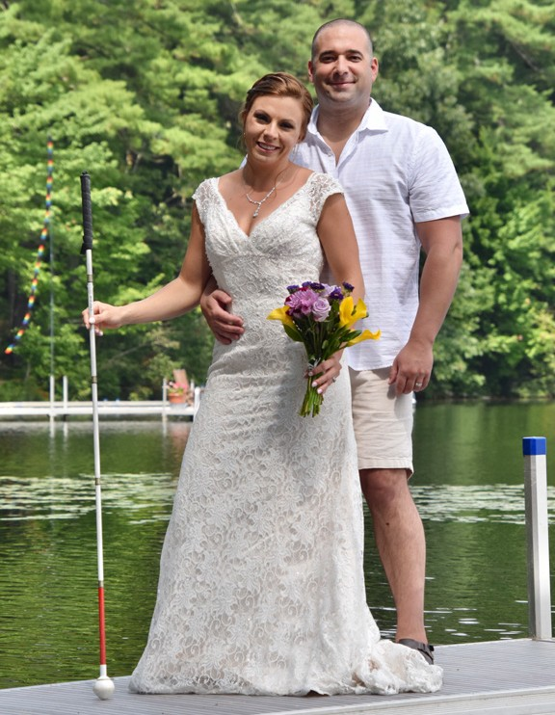
Sara in a wedding dress standing next to her husband holding a white cane in one hand and flowers in the other.

I cannot stress enough the value of the Rehabilitation Center at The Iris Network for people with vision loss. Before I knew it, I was using a computer with the help of JAWs, a screen reader, and learning to use the keyboard to navigate instead of a mouse.
I learned how to walk confidently and safely with my white cane. I also used an app on my phone to help me map out public transportation—learning bus routes, schedules, and how to get to different stops.
Because of The Iris Network, my world became bigger. Things were accessible once again. I no longer felt limited by my visual impairment.

Will you make a gift of $50 to The Iris Network today? For many of us with vision loss, there is no medicine to fix our eyesight. The Iris Network is the resource we need in order to return to or enter the workforce.
While mine is a success story, there are many people with vision loss and blindness who are living in a world that seems more difficult. The unemployment rate for people with visual impairment staggers around 70%. There is a huge, untapped, and eager workforce, many of whom don’t even realize the technology and tools that are available to help them feel fulfilled in careers and involved in their communities.

This is why The Iris Network relies on friends like you for financial support.
Your gift today helps fund the Rehabilitation Center so that Vision Rehabilitation Therapists (VRTs) can offer practical and life-changing technology and education to those with visual impairment.
Without you, The Iris Network can’t introduce people to the latest tools and software that make using a computer possible. Without you, they wouldn’t know how to pick an outfit from their closet for work. Without your help, those who are unable to drive might never know how to navigate public transportation or walk with a white cane to get to their job.

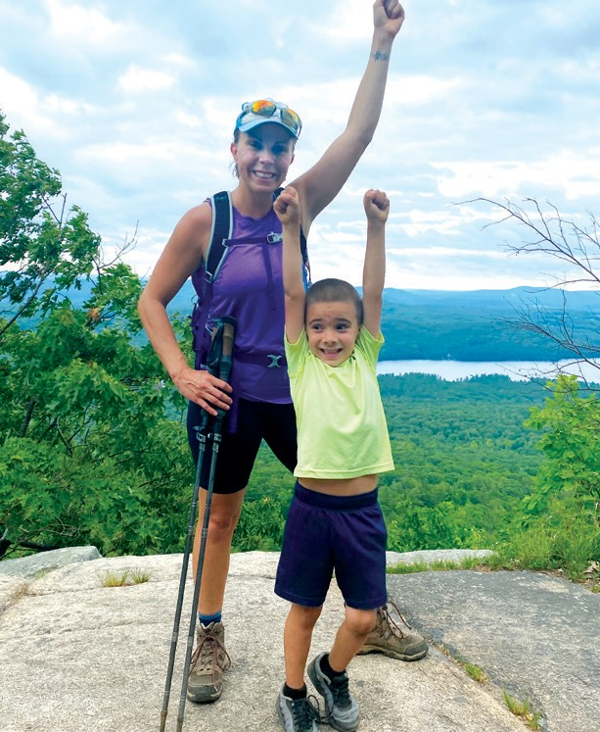
Sara and her son cheering on top of a mountain.

I know because I’ve been there. Now, I am so proud to say that I am employed by The Iris Network as a VRT-Intern. Even if I didn’t find this position—about which I’m so personally passionate—I have faith that I would have found other competitive and integrated work thanks to the skills I learned at the Rehabilitation Center.
I’ve never felt more confident and ready to take on challenges—personally and professionally. What I needed was someone like you who believed in me and my ability to live a fulfilling and valuable life.
The Iris Network needs caring, compassionate people like you to lend a helping hand to your neighbors with vision loss. I can’t thank you enough for providing the tools and education that changed my life.
Together, let’s do it for those who deserve the same fulfillment! Gratefully yours,

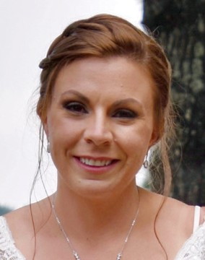 Sara Nappi, VRT-Intern
PS. I’ve seen firsthand how your generosity can help people with vision loss—both as a client and as an employee of The Iris Network! The technology and skills that your gift of $50 provides are invaluable. Visit theiris.org/services/rehabilitation-center to hear more of my story and to find out how you gift fuels the Rehabilitation Center! Thank you!

